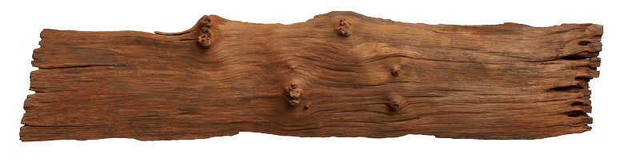



By Rebecca Mitchell

Version 1.0.0

Wednesday, September 28, 2016



Paddle Baddle is an over the top arena brawl where the arena is a lake and the players are in canoes! It’s a fun and light hearted take on the arena brawl genre that’s good for the whole family, from Fido to grandma. Team mates must work together to battle environmental elements in a hectic lake, get to their opponents and tip that canoe!



It’s time for some god ol’ family camping! This time you have some family beef to settle and what better way to do it knocking them out of their canoe. Player’s control a family of campers battling for victory in a no holds bar Lake Battle!

Paddle Baddle is a local cooperative multiplayer game where 2 players take control of a canoe, they have to work together in order to move the canoe and for a strategy to take down the other team. The battle is a timed round and whichever team has been tipped the least is the victor.



**Crazy Paddles!**

**Arena Brawl for the whole family!**

**Teamwork is a Must!**













